Team Number:
Time:
Rank:

SMALL BUSINESS
MANAGEMENT TEAM
(510)

PRELIMINARY
NATIONAL 2020

TOTAL POINTS ___________ (170)

Judges: Please double check and verify all
scores and answer keys!

Property of Business Professionals of America.
May be reproduced only for use in the Business Professionals of America
Workplace Skills Assessment Program competition.

Description:
The team will use strategic planning and problem-solving skills to provide solutions to the business case study provided. At State and National level, teams will be presented with an additional element to the scenario that requires revision of their final presentation.

Modification at National Preliminary Competition:
In your discussions with Mr. Jackson, you find that one of the areas in which his company struggles is donations to non-profit organizations. He has never had a policy in place and always donates when asked. His donations range from physical products to time designing to cash donations. He has always felt that by donating to causes and helping out that his business would gain more customers through either the advertisement or word-of-mouth by those he helps. He found that some years he ends up donating almost twice as much as he would have felt comfortable with. How has his lack of a donation policy affected his revenue stream? Should he adopt a policy? If so, what should it include? Can his donation to non-profits help his revenue stream?

Initial Case Study
Fred Jackson, owner of ABC Graphics, has noticed that his company has lost a significant amount of revenue over the past few years. Mr. Jackson opened his business in 2005 after graduating from a graphic design program. He is very knowledgeable in the tools used in the graphic design industry. At first, his company thrived and Mr. Jackson was the recipient of many local awards for his successful business. His success continued through 2008 where revenues plateaued and then starting in 2011 began to steadily decrease. This is depicted on the graph below.

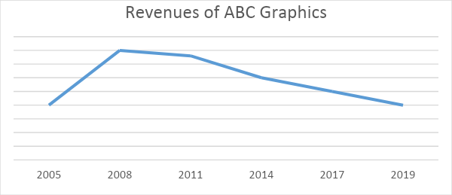

Mr. Jackson was concerned that the market had potentially become saturated and that all graphic design businesses were suffering. However, after doing some market research, there are newer companies opening, charging similar prices and are continuing to be successful. The research also showed that most organizations are still paying other companies to complete their graphic design work rather than completing it through their own employees.

ABC Graphics has on staff a salesman and an administrative assistant. Mr. Jackson completes all the graphic work himself. The salesman’s job is to find opportunities for Mr. Jackson to complete work for companies. The salesman then takes Mr. Jackson’s designs to the companies for their final approval and purchase. Mr. Jackson hired the salesman in 2008 when he noticed that sales began slowing down. The salesman has provided ample opportunity for graphics to be sold, but the final products are not being bought. Most potential clients prefer the design of a competing graphics company.

Prepare a presentation for Mr. Jackson with your suggestions for his company including, but not limited to, the questions below.

- What might be a reason that organizations are buying artwork/logos from other graphics companies and not ABC Graphics?
- What are some potential marketplace influences that could be affecting ABC Graphics’ revenue stream?
- What is the business lacking to meet the needs of an ever-changing market?
- What changes should the owner make to foster/develop future success?

Teams who do not submit an entry that follows this topic will be disqualified.

